ALEJANDRO SANTORUM VARELA
2nd Hand in – Exercises EDAT

EXERCISE 13
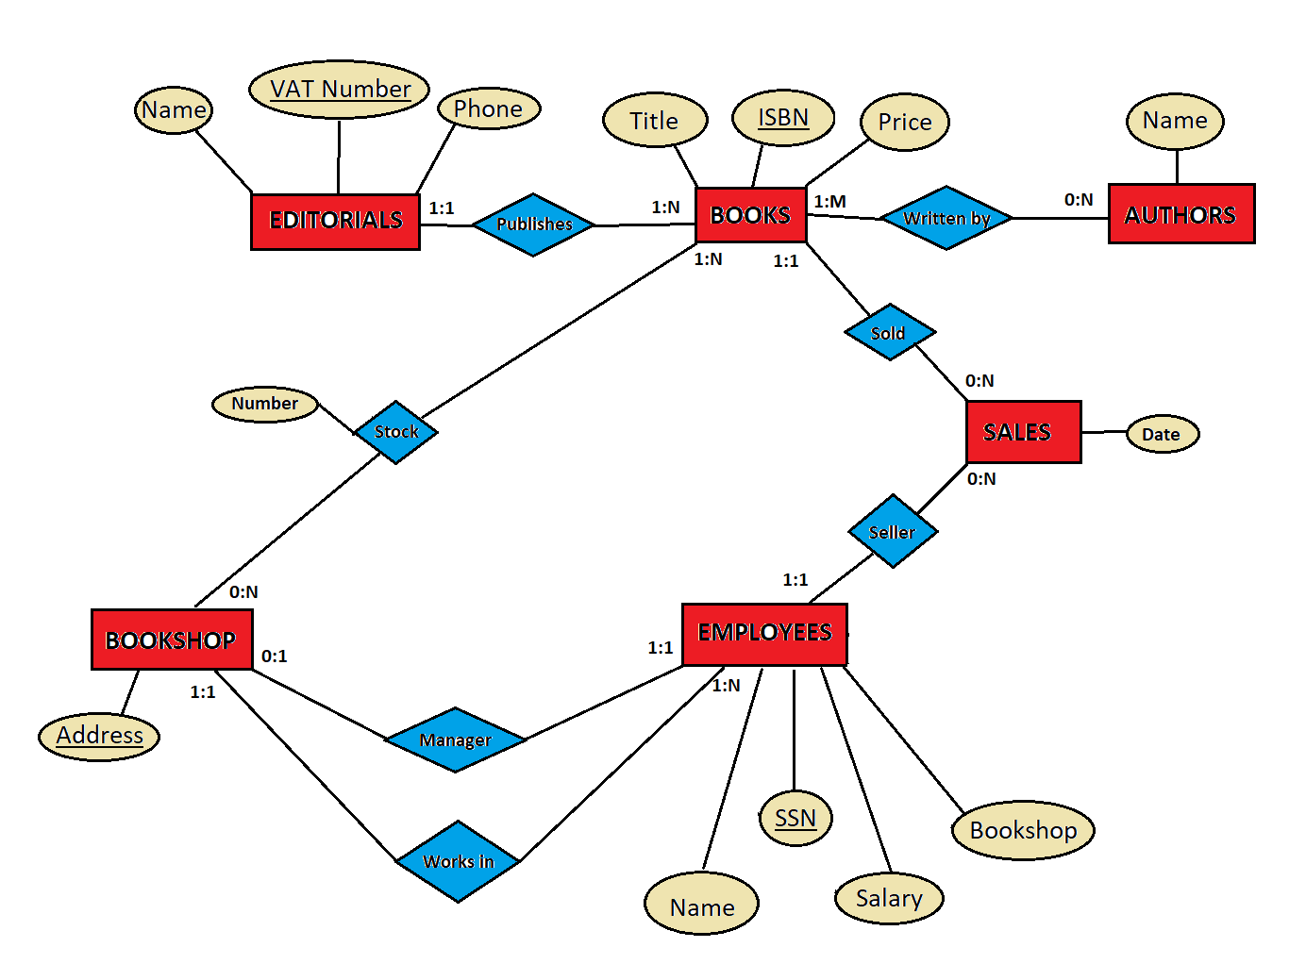

EXERCISE 14
